Written Report

In order to minimize costs, the optimal group of lease agreements would be:

* 15 1-month leases starting on November
* 5 4-month leases starting on November
* 5 5-month leases starting on November
* 10 1-month leases starting on January

With this group, you would have a minimum cost of $16,625 and meet the demand requirements.



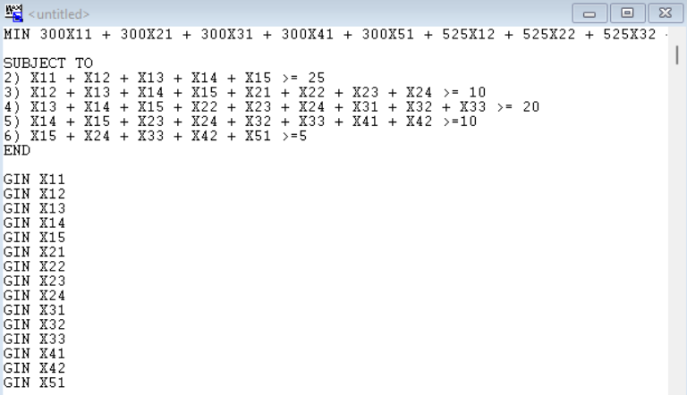



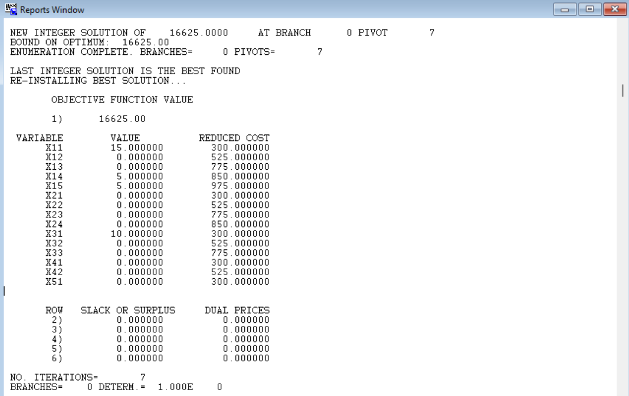

| Constraint | Proof of constraint being followed |
| --- | --- |
| All variables are forced integers | Figure B shows all variable values being whole numbers |
| X11 + X12 + X13 + X14 + X15 >= 25 | 15 + 0 + 0 + 5 + 5 >= 25  25 >= 25 |
| X12 + X13 + X14 + X15 + X21 + X22 + X23 + X24 >= 10 | 0 + 0 + 5 + 5 + 0 + 0 + 0 + 0 >= 10  10 >= 10 |
| X13 + X14 + X15 + X22 + X23 + X24 + X31 + X32 + X33 >= 20 | 0 + 5 + 5 + 0 + 0 + 0 + 10 + 0 + 0 >= 20  20 >= 20 |
| X14 + X15 + X23 + X24 + X32 + X33 + X41 + X42 >=10 | 5 + 5 + 0 + 0 + 0 + 0 + 0 + 0 .>= 10  10 >= 10 |
| X15 + X24 + X33 + X42 + X51 >=5 | 5 + 0 + 0 + 0 + 0 >= 5  5 >= 5 |